Designing IoT Face Recognition Robot

Shreenivas Telkar   
*Department of Instrumentation Engineering*  
*Vishwakarma Institute of technology*Pune, India  
[shreenivas.telkar18@vit.edu](mailto:shreenivas.telkar18@vit.edu)

Atharva Vidye  
*Department of Instrumentation Engineering*  
*Vishwakarma Institute of technology*Pune, India  
[atharva.vidye18@vit.edu](mailto:atharva.vidye18@vit.edu)Onkar Thombare  
*Department of Instrumentation Engineering*  
*Vishwakarma Institute of technology*Pune, India  
[onkar.thombare18@vit.edu](mailto:onkar.thombare18@vit.edu)

Parikshit Wagh  
*Department of Instrumentation Engineering*  
*Vishwakarma Institute of technology*Pune, India  
[parikshit.wagh18@vit.edu](mailto:parikshit.wagh18@vit.edu) Sanket Veer  
*Department of Instrumentation Engineering*  
*Vishwakarma Institute of Technology,* Pune, India[sanket.veer18@vit.edu](mailto:sanket.umredkar18@vit.edu)

Archana Chaudhari  
*Department of Instrumentation Engineering*  
*Vishwakarma Institute of technology*Pune, India  
[archana.chaudhari@vit.edu](mailto:archana.chaudhari@vit.edu)

***Abstract*—The detection of human facial emotions is a major goal in the current world of technology. Robotic applications are used in almost all domains. In order for us to communicate effectively with robots, face recognition is essential. The project aims to develop and implement a new face recognition system based on CV (Computer Vision) and IoT (Internet of Things). The program is revealed in many facial images of people from different backgrounds and backgrounds. This creates a training database that helps in facial recognition. Then, when the robot detects a human face, it initiates a face recognition algorithm that uses the Local Binary Pattern (LBP) method.**

***Keywords—Face Recognition, Raspberry Pi, Computer Vision, Internet of Things.***

# Introduction

Face recognition is a way of image processing to find a person's face that requires a camera to take a picture of a person's face. Image processing will search for an important aspect of a person's face in a photo, so something else will be considered. Image processing detects human faces using various algorithms and methods, for example: AdaBoost, Viola-Jones method, Roberts Cross method, and more. To distinguish seeing a person's face can be used; Local Binary Pattern (LBP), Hidden Markov Model (HMM), Bayesian, Support Vector Machine (SVM), and more.

In this paper, the image is captured by a camera module and face recognition and face recognition algorithms are used using the Raspberry Pi. The digital image of the obtained face is separated by pixels used for continuous processing. The features of this image are compared to a pixel with a pixel with face features in the database.The Arduino computer hardware unit controls functions such as temperature recording, LED blinking and also controls robot traffic with a servo motor.

Paper will be described a development of Social

Robots which can recognize and track human faces. The real-time face detection and recognizing human face.

# LITERATURE SURVEY

* In [1], the Face Recognition System (FRS) process can be divided into two main components. The first part is processing the image and the second part is the recognition techniques. The image processing component contains facial image detection by scanning, image enhancement, image cutting, filtering, edge detection and feature removal. The second part contains artificial intelligence formed by genetic algorithms and has many face detection methods [2].
* The facial recognition algorithm was broadly divided by researchers into (M. Singh et al. [4]) two alternatives, namely, discriminatory and productive methods [4]. Discrimination methods use basic information such as age, weight, bone structure, and body size given to be analyzed and the production method describes how to apply the data to the model.
* Many face recognition methods are divided (Ming-Hsuan Yang et al. [5]) into four main categories, namely, Information-based approach, Invariant feature method, image compression, and visual-based methods. It touches the face to find related facial features, to detect fixed features while changing shape, change in brightness or other changes in the face [5] The pattern matching method defines all facial features to match between the inclusion pattern and the calculated reference to obtain face detection.
* Face detection in color photographs is difficult when the images have complex backgrounds under various light and the skin detection is reduced and gives false positive effects. The novel algorithm presented by the authors (Li Zou and Seiichiro Kamata [10]) proposed an algorithm for the same skin color acquisition algorithm to improve the accuracy of detection and detection separations from the Gaussian composite model and the Adaboost training algorithm followed to reduce profits false [10].

There are various face recognition techniques available. Over the years many techniques have been proposed some are listed below :

* **Feature-based approach :**A feature-based approach will process a picture to include distinctive and distinct facial expressions, for example, eyes, mouth, nose, etc.
* **Video-based face recognition:** Focuses real-time facial recognition by ordering photos recorded on a video camera. The most notable use of facial solutions is mainly to guide safety requirements. This section contains face detection, recording, and scanning.
* **Face recognition from sensory :**This approach will help to achieve features that depend on facial shapes and clear cheeks without interrupting changes that occur due to lighting, posture, and background collections that will influence the 2D system.
* **Neural Network approach :** There are various ways to perform feature extraction using neural networks. For example, Intrator et al. suggest a paved or slightly guarded path. Combine unintentional feature removal techniques with targeted techniques to find features that are suitable to reduce the classification error. Separate, neural transmission networks (FFNN) can be used.

# Implementation

For Face Recognition we have used Python 3.6 using the Anaconda Spyder platform for debugging and coding. After that, we implemented it in Raspberry Pi Board 3. We have used “face_recognition” library to recognize the face and used “pyttsx3” library to give the voice output when the face is recognized. Also used library “requests” and webhook Integromat to store the user’s data on Google Excel sheet. Implemented DHT11 temperature sensor to Raspberry Pi Board 3 to measure the temperature of the user and it will be recorded in the Google Excel sheet.

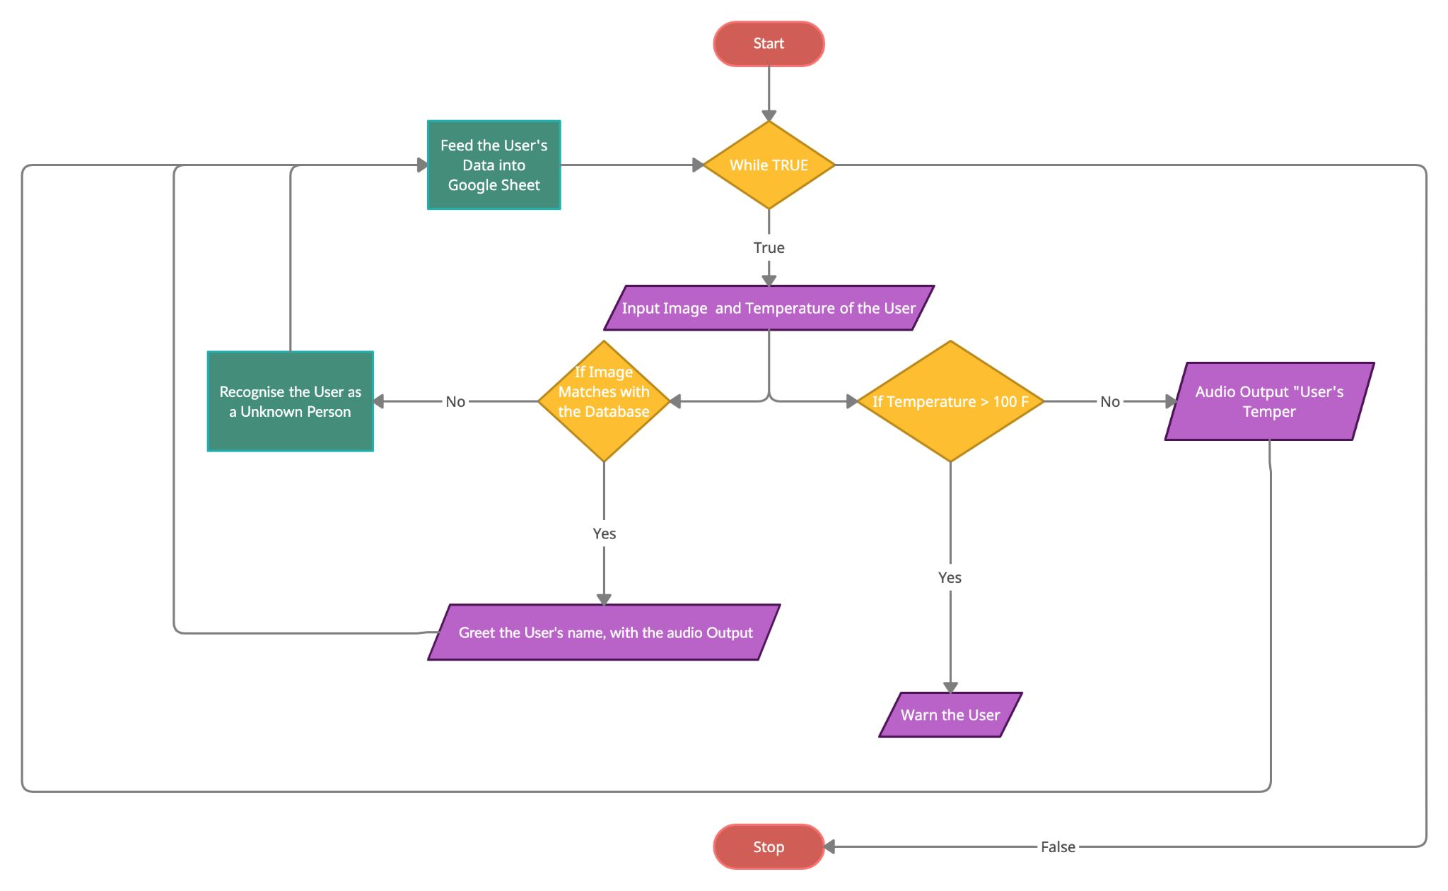

## *Face Recognition*

* The face detector we use is made using the classic Histogram of Oriented Gradients (HOG) feature combined with a linear classifier, an image pyramid, and sliding window detection scheme. The pose estimator was created by using dlib’s implementation of the paper. When using a distance threshold of 0.6, the dlib model obtains an accuracy of 99.38% on the standard LFW face recognition benchmark, which is comparable to other state-of-the-art methods for face recognition as of February 2017. This accuracy means that, when presented with a pair of face images, the tool will correctly identify if the pair belongs to the same person or is from different people 99.38% of the time.

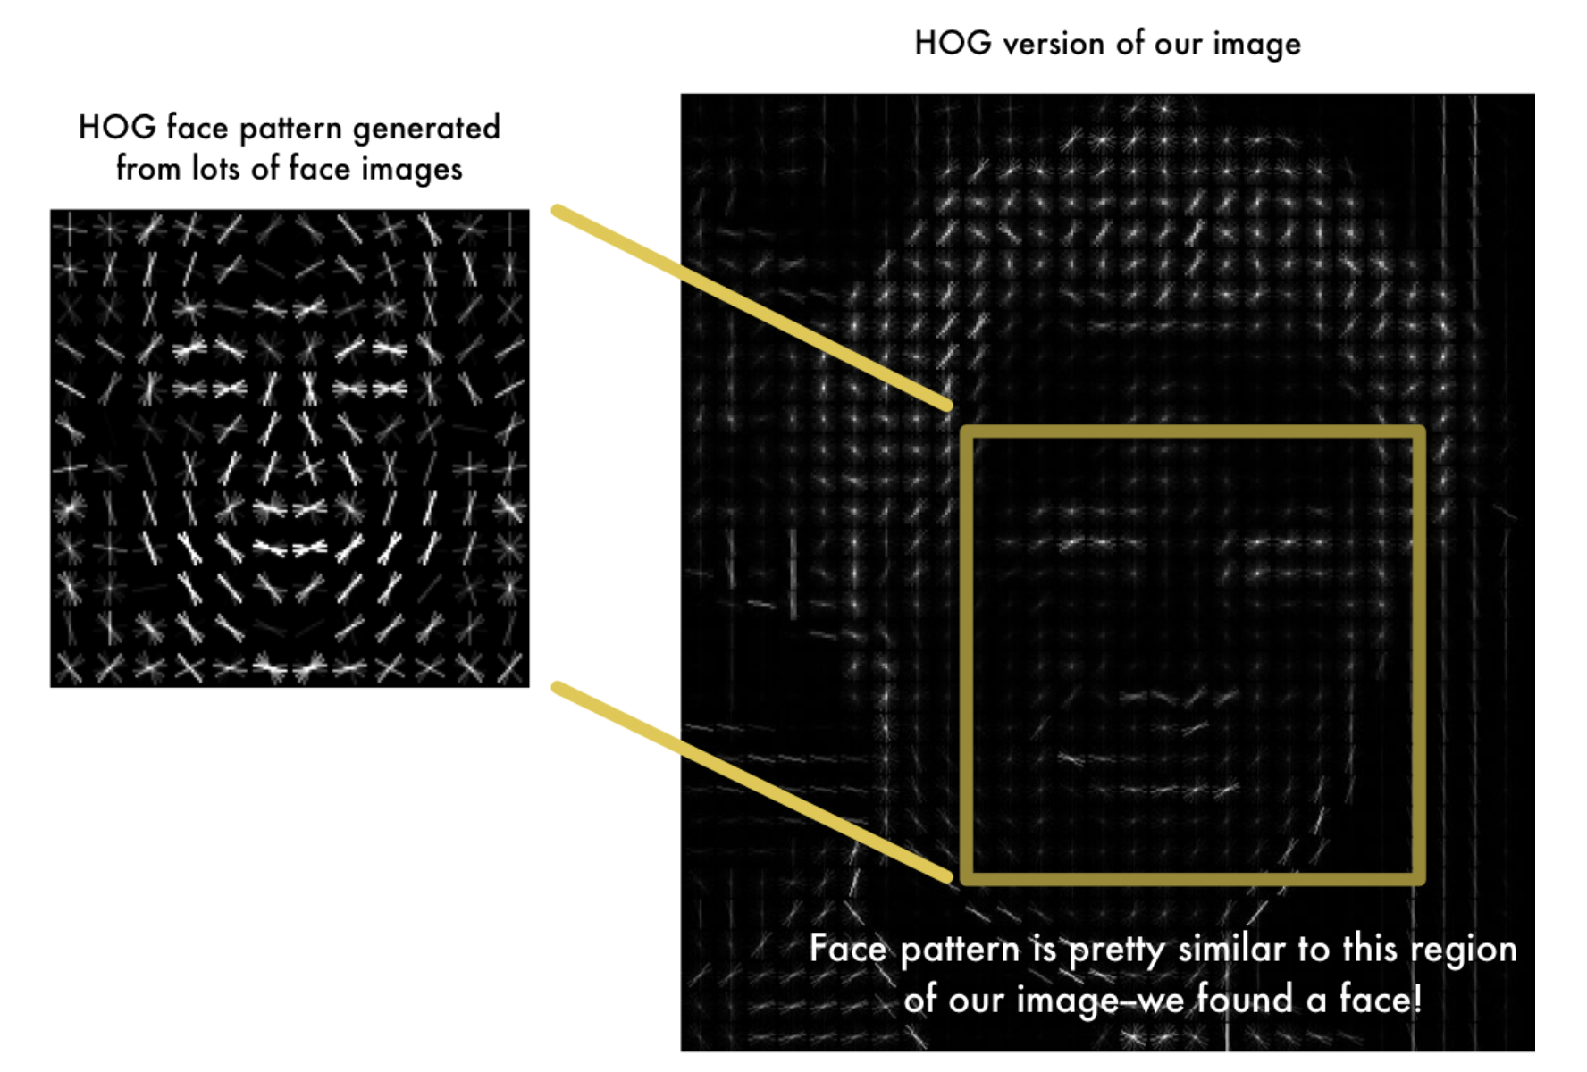

*HOG*

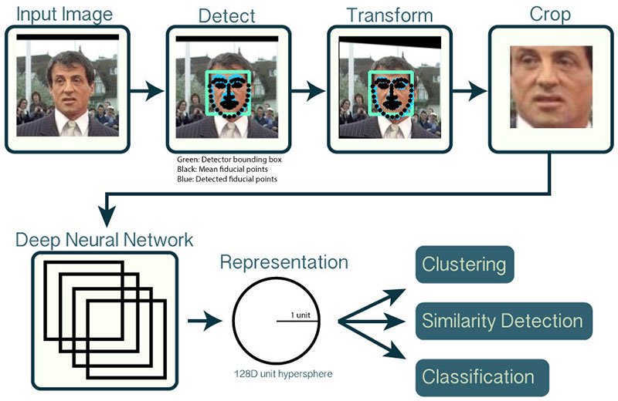

* 1. Pyttsx3
* pyttsx3 is a text-to-speech conversion library in Python. Unlike alternative libraries, it works offline and is compatible with both Python 2 and 3. An application invokes the pyttsx3.init() factory function to get a reference to pyttsx3. Engine instance. It is a very easy to use tool which converts the entered text into speech.The pyttsx3 module supports two voices, first is female and the second is male which is provided by “sapi5” for windows.

C. Webhooks

* Any application that is connected to the Internet and allows the sending of HTTP requests can send webhooks to Integromat. To connect such an app to Integromat, add the Webhooks > Custom Webhook instant trigger module to your scenario. When setting this trigger, click on the Add button next to the Webhook field and enter a name for the new webhook.

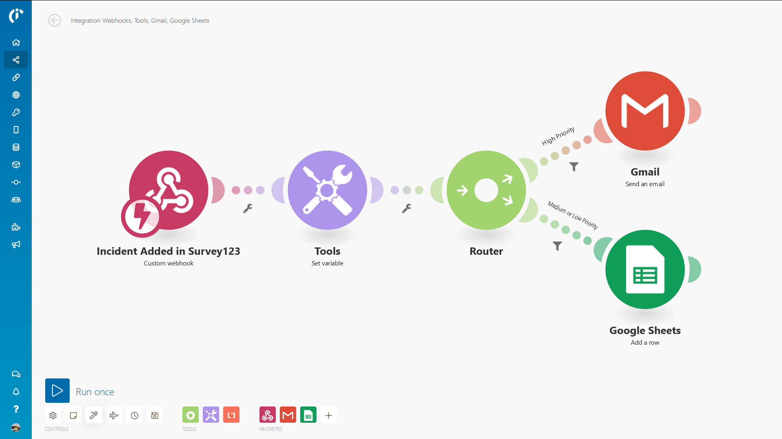

D. DHT11

* The DHT11 is a basic, ultra low-cost digital temperature and humidity sensor. It uses a capacitive humidity sensor and a thermistor to measure the surrounding air, and spits out a digital signal on the data pin (no analog input pins needed). It's fairly simple to use, but requires careful timing to grab data. The only real downside of this sensor is you can only get new data from it once every 2 seconds, so when using our library, sensor readings can be up to 2 seconds old.For measuring the body temperature, we are using DHT11 temperature sensorThe sensor measures temperature via NTC temperature sensor. It is a thermistor mounted on the surface.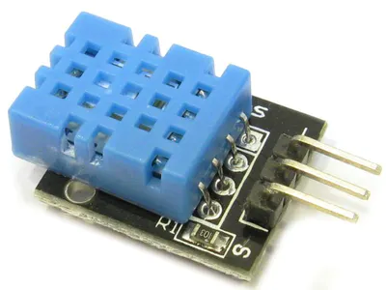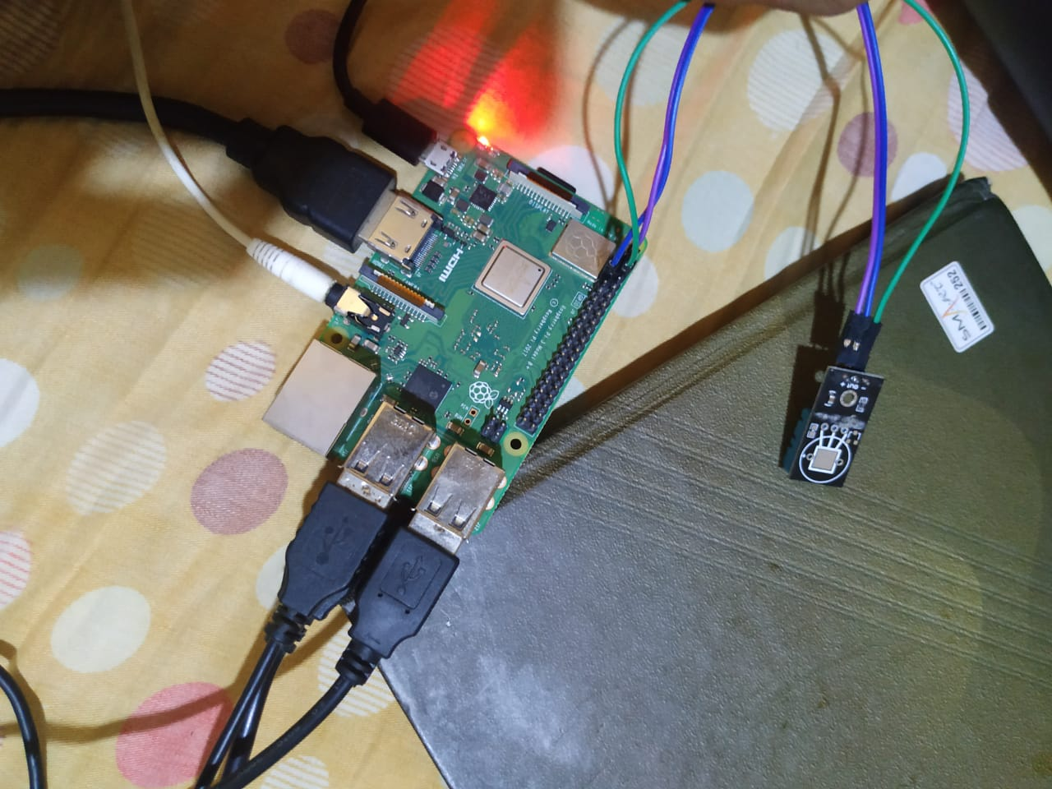

# Results

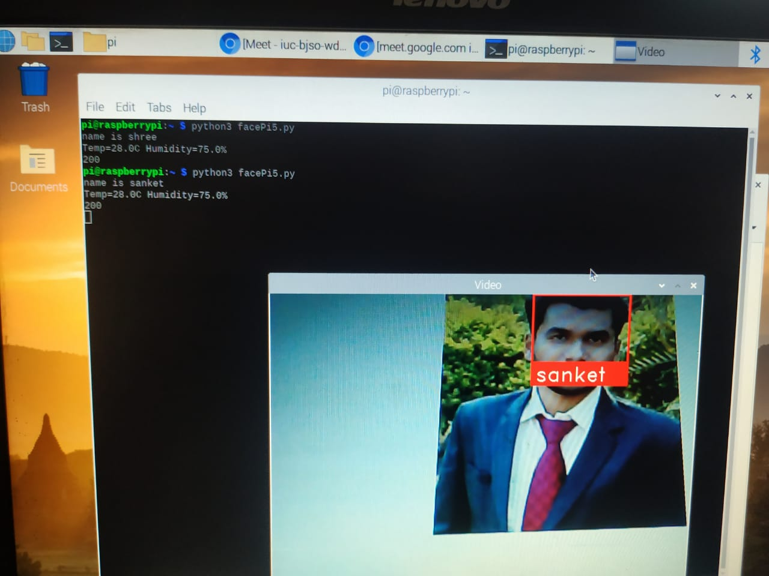

*Fig. 1*

Face is detected and recognised successfully and output is displayed including Name, Temperature, Humidity and status of data updation in the database.



Fig.2

Data is updated in Google Sheet which includes Date, time , Name of person and Temperature.

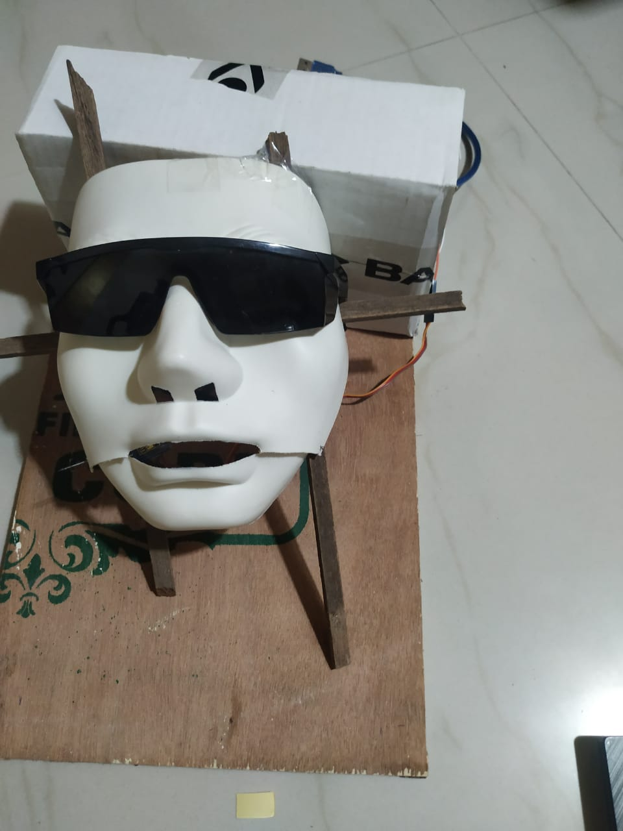

*Fig.3*

Human face replica which performs lipsing action and eyes blink.

# Application

This type of system can be used for various applications such as

* In Office, it will be able to record the attendance and also with the corresponding temperature of that person, which will indeed help us in this pandemic situation.
* It can also be used in hospitals as well.

# Conclusion

In this research a Designing IoT Face Recognition Robot which can recognize and track the human face. The face recognition is processed by the algorithm based on Python 3 (with the OpenCV library) by using Raspberry Pi. It was convenient to use the ‘request’ library to post the request to append data in the database. Temperature sensor was interfaced successfully to get the user's temperature and add it to the database.

##### References

1. J. Galbally, C. McCool, J. Fierrez, S. Marcel, and J. Ortega-Garcia, “On the vulnerability of face verification systems to hill-climbing attacks”, Pattern Recognition, Vol. 43. No. 3, 2010, pp.1027–1038.
2. Rathi R., Chaudhary M., Chandra B., “An Application of Face Recognition System using Image Processing and Neural Networks”, International Journal of Computer Technology and Application, Vol 3(1), Jan-Feb 2012.
3. ] S. Lawrence, C. L. Giles, A. C. Tsoi, and A. D. Back, "Face Recognition: A Convolutional Neural Network Approach," IEEE Transactions on Neural Networks, Special Issue on Neural Networks and Pattern Recognition, pp.1-24, 1997.
4. M. Singh, S. Nagpal, R. Singh, and M. Vatsa: On Recognizing Face Images with Weight and Age Variations, IEEE Access, vol. 2, pp. 822–830, 2014.
5. Ming-Hsuan Yang, David J. Kriegman, Narendra Ahuja: Detecting Faces in Images: A survey: IEEE Transaction on Pattern Analysis and Machine Intelligence. Vol. 24, No. 1, January 2002, pp. 34–58.
6. Li Zou and Sei-ichiro Kamata: Face Detection in color Images based on skin color models: TENCON 2010 - 2010 IEEE Region 10 Conference, ISSN: 2159-3442, Print ISBN:978-1-4244-6889-8, pp. 681–686, DOI:10.1109/TENCON.2010.5686631.